I-15 PeMS Analysis
This analysis uses PeMS data to characterize the level of service on the I-15 express lanes (EL). It compares travel speeds for the two closest stations on express lanes and general purpose (GP) lanes. The analysis is limited and does not support a full corridor assessment, because of the limited number of healthy express lane stations.
Selected Healthy Stations
Station health is evaluated before the speed analysis. PeMS reports traffic conditions in hourly records for each station. These records are built from readings collected by lane detectors at a given location. PeMS contains observations on data-quality which show how many of expected detector readings were observed and used to calculate the station’s reported speed and volume for each hour.
A station is identified as “healthy” based on two thresholds:
- PeMS observed percent (for a station-hour record) is at least 75% (that is, at least 75% of expected detector readings were captured for a given hour); and
- At least 75% of the expected weekday station-hour records between the station’s first and last available observations are complete. This threshold is based on the “complete records share” which measures how often a station produced a usable hourly record across the full analysis period. For this assessment, the full analysis period is January 2023 through May 2026.
Table 1 reports the average value for each metric across stations and the number of stations meeting the 75% threshold (N > 75%). A station can have a relatively high PeMS percent observed, but a lower complete records share if many hours are missing. The analysis included 130 general purpose lane stations and 21 express lane stations from. Only 9 of the 21 express lane stations met both thresholds required to be classified as healthy. The table highlights that station health is influenced both criteria.
Table 1. Station Health Assessment
Direction | Facility | Total Stations | Healthy Stations | Unhealthy Stations | Share Healthy | PeMS % Obs |  | Complete Records Share
 |  |  |  |  |  | Avg | N  > 75% | Avg | N  > 75%
NB | EL | 11 | 5 | 6 | 45% | 61% | 5 | 66% | 6
SB | EL | 10 | 4 | 6 | 40% | 59% | 4 | 63% | 5
NB | GP | 70 | 38 | 32 | 54% | 68% | 38 | 69% | 40
SB | GP | 60 | 38 | 22 | 63% | 71% | 38 | 72% | 39
Note: Identification of healthy stations is based on data covering January 2023 to May 2026.

With “healthy” EL stations identified, the analysis then matches it to the nearest healthy GP station in the same direction. Pairing sensors on the EL and GP lanes is based on post mile. Table 2 below identifies the nine pairs. (Attachment 1 provides a map for reference.)’
Table 2. Paired EL and GP Stations
Direction | Facility | Station Name | Post Mile
NB | EL | 15 NB HOV N/O Carroll Canyon Rd | 15.637
NB | GP | 15 NB N/O Carroll Cyn Rd | 15.639
NB | GP | 15 NB Green Valley Creek | 25.284
NB | EL | 15 NB HOV Green Valley Creek | 25.286
NB | GP | Felicita/Citracado Pkwy to 15 NB | 29.031
NB | EL | 15 NB HOV Felicita/Citracado Pkw | 29.031
NB | GP | Auto Park Way/9th Ave to 15 NB | 30.469
NB | EL | 15 NB HOV N/O Auto Park Way/9th | 30.469
NB | GP | Valley Parkway to 15 NB | 30.975
NB | EL | 15 NB HOV S/O Rte 78 | 31.157
SB | EL | 15 SB HOV Center City Pkwy | 0.148
SB | GP | 15 SB N/O National Ave | 0.368
SB | EL | 15 SB HOV S/O Pomerado/W Bernard | 25.878
SB | GP | 15 SB S/O Pomerado/W Bernardo | 25.882
SB | GP | 15 SB S/O Via Rancho Parkway | 26.690
SB | EL | 15 SB HOV S/O Via Rancho Parkway | 26.694
SB | EL | 15 SB HOV N/O Felicita/Citracado | 29.756
SB | GP | Auto Parkway/9th Ave to 15 SB | 30.216

Selected-Station Managed Lane vs. GP Speed Comparison
Across the selected stations, average travel speeds varied. The table below summarizes travel speeds detected at paired stations.
- Across the five Northbound stations, the average travel speeds were roughly comparable. During AM Peak periods the GP lanes appear to have slightly higher on travel speeds during the AM peak periods and slightly lower speeds during the PM peak period.
- Southbound had four stations. Compared to GP lanes, travel speeds on the express lanes were roughly comparable during AM peak hours and faster during PM peak period.
Average Speed for Station Pairs - FY26 (July 2025-May 2026)
Station | Post Mile | AM Peak |  | PM Peak
Station | Post Mile | GP Speed  (mph) | EL Speed  (mph) | GP Speed  (mph) | EL Speed  (mph)
Northbound
15 HOV Felicita/Citracado Pkw | 29.031 | 66.3 | 64.7 | 58.3 | 51.2
15 HOV Green Valley Creek | 25.286 | 64.2 | 63.7 | 53 | 54.7
15 HOV N/O Auto Park Way/9th | 30.469 | 61.2 | 64.5 | 49.2 | 48.2
15 HOV N/O Carroll Canyon Rd | 15.637 | 63.6 | 42.4 | 45.9 | 52
15 HOV S/O Rte 78* | 31.157 | 55.1 | 64.2 | 43.3 | 43.7
Average (Min, Max) |  | 62.1  (55.1, 66.3) | 59.9  (42.4, 64.7) | 49.9  (43.3, 58.3) | 50  (43.7, 54.7)
Southbound
15 HOV Center City Pkwy | 0.148 | 64.6 | 52.9 | 34.2 | 64
15 HOV N/O Felicita/Citracado | 29.756 | 43.2 | 51.2 | 66.2 | 64.6
15 HOV S/O Pomerado/W Bernard | 25.878 | 57.8 | 57.1 | 68.8 | 64
15 HOV S/O Via Rancho Parkway | 26.694 | 56 | 55.7 | 68.2 | 63.7
Average (Min, Max) |  | 55.4  (43.2, 64.6) | 54.2  (51.2,57.1) | 59.3  (34.2,68.8) | 64.1  (63.7, 64.6)
Notes: Pink indicates EL average speed was at least 10% slower than GP. Green indicates EL speed was at least 10% faster than GP.
*Northbound PM Peak period travel speed recorded large changes across fiscal years (speeds slowest in FY24).

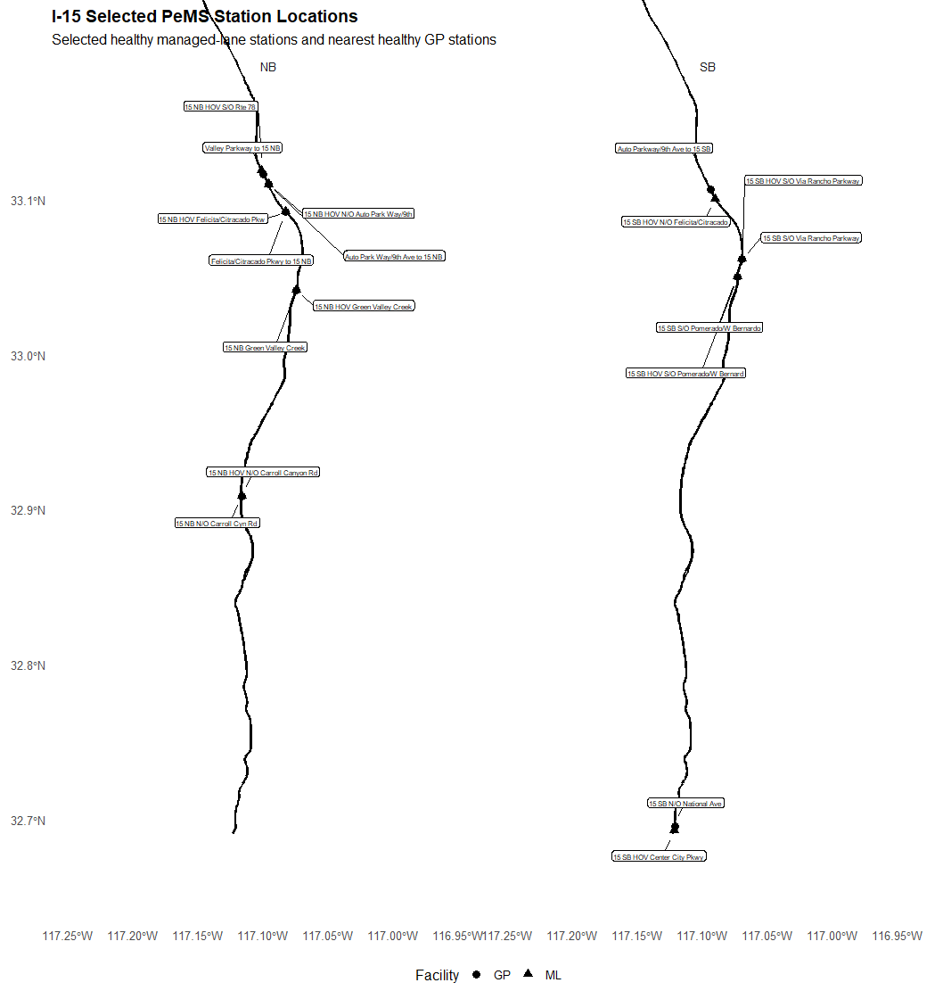
Attachment 1. Map of Station Locations

